Standards

1.Use Century Gothic Font with maximum size 20 (depend on how much text the screen contain) and all variable should be in Times Roman font and size should match the size of Century Gothic font. Pls refer below

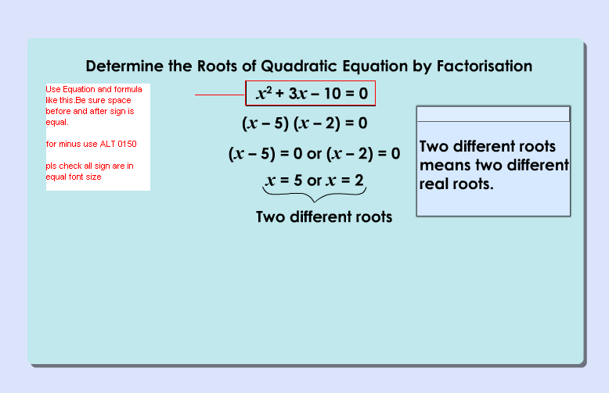
Use bubble popup refer sb
And also follow this type of popup when mention in SB

2. pls check all files with sb whether it is produced as per the sb.

3.all text should be center aligned and enough line spacing.

4.Present the content clearly and sink with vo.

5.pls check all files whether its working correctly especially activity.

6.use the full stage size and present the text clearly

7.No need for text area as TSS remove it.

8.use the background color contrast to the text so that text can seen clearly when see in projector.

